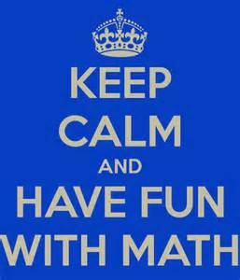

Keep Calm and Engage by Talking and Writing about Math

CMC South Conference
Palm Springs, CA
November 1-2, 2013

Presenter
Jennifer Branch
algebranch@yahoo.com

Standard 3: Construct viable arguments and critique the reasoning of others
The Standard:
Mathematically proficient students understand and use stated assumptions, definitions, and previously established results in constructing arguments. They make conjectures and build a logical progression of statements to explore the truth of their conjectures. They are able to analyze situations by breaking them into cases, and can recognize and use counterexamples. They justify their conclusions, communicate them to others, and respond to the arguments of others. They reason inductively about data, making plausible arguments that take into account the context from which the data arose. Mathematically proficient students are also able to compare the effectiveness of two plausible arguments, distinguish correct logic or reasoning from that which is flawed, and—if there is a flaw in an argument—explain what it is. Elementary students can construct arguments using concrete referents such as objects, drawings, diagrams, and actions. Such arguments can make sense and be correct, even though they are not generalized or made formal until later grades. Later, students learn to determine domains to which an argument applies. Students at all grades can listen or read the arguments of others, decide whether they make sense, and ask useful questions to clarify or improve the arguments.
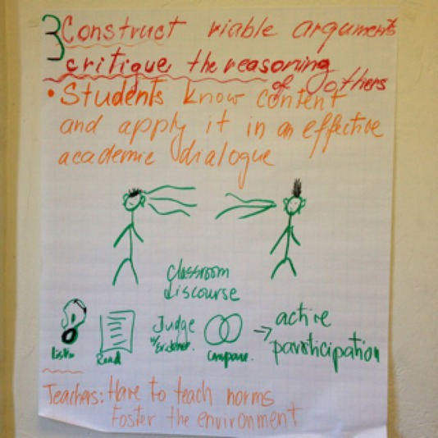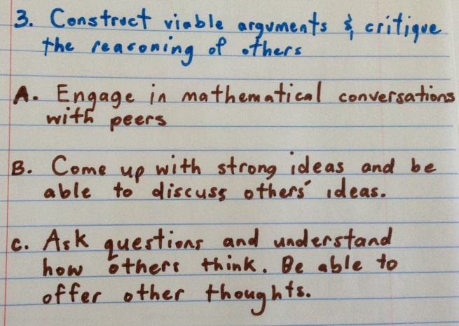
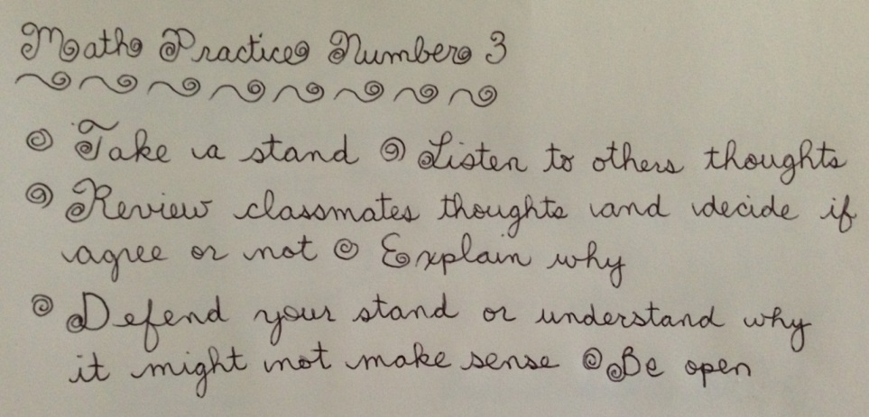
Standard 6: Attend to precision
The Standard:
Mathematically proficient students try to communicate precisely to others. They try to use clear definitions in discussion with others and in their own reasoning. They state the meaning of the symbols they choose, including using the equal sign consistently and appropriately. They are careful about specifying units of measure, and labeling axes to clarify the correspondence with quantities in a problem. They calculate accurately and efficiently, express numerical answers with a degree of precision appropriate for the problem context. In the elementary grades, students give carefully formulated explanations to each other. By the time they reach high school they have learned to examine claims and make explicit use of definitions.

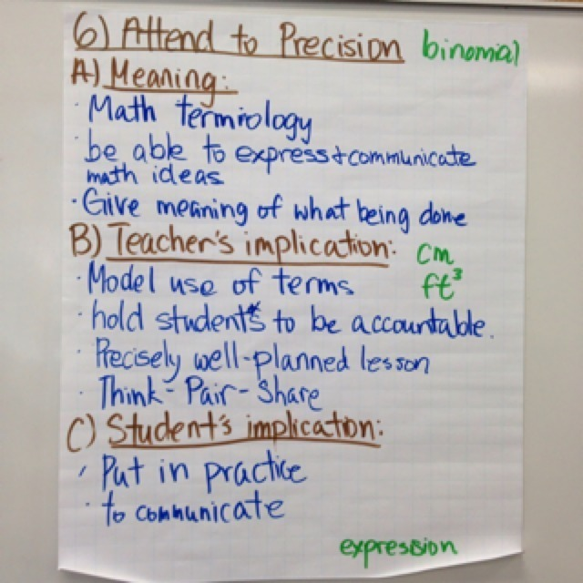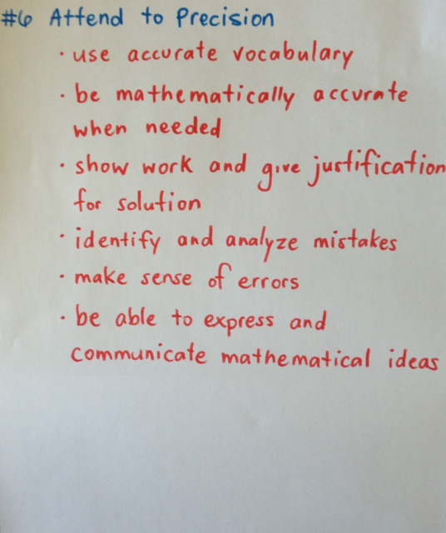

Eliminate It!
square | trapezoid
pentagon | rhombus

Cross out the term that does not belong with the others. Explain your reasoning below.

Eliminate It!
x² - 4 | - x² + 1
x + 3 | x² – 6x + 9

Cross out the expression that does not belong with the others. Explain your reasoning below.

Eliminate It!

Cross out the shape that does not belong with the others. Explain your reasoning below.

Eliminate It!
½ | ¾
⅔ | ⅓

Cross out the fraction that does not belong with the others. Explain your reasoning below.

Eliminate It!
diameter | chord
tangent | secant

Cross out the term that does not belong with the others. Explain your reasoning below.

Now you create one and Eliminate It!

Cross out the term that does not belong with the others. Explain your reasoning below.

Eliminate It!

Cross out the term that does not belong with the others. Explain your reasoning below.

Eliminate It!

Cross out the term that does not belong with the others. Explain your reasoning below.

Agree or Disagree?

Read each statement. Decide if you agree or disagree with the statement, then record evidence to support your decision.

Statement | Agree or Disagree? | Evidence to Support your claim
A square is a rectangle.

In y = mx + b equations the ‘b’ represents the slope of your line.

The absolute value of -9 is equal to the absolute value of 9: | -9 | = | 9 |?

log₂ 8 = 3

A chord is a line which passes through at least two points of a curve.

-3 is an example of an integer and a whole number.

The chain rule is a function which gives the slope of a curve; that is, the slope of the line tangent to a function.

Agree or Disagree?

Read each statement. Decide if you agree or disagree with the statement, then record evidence to support your decision.

Statement | Agree or Disagree? | Evidence to Support your claim

1. Describe the graph of any trigonometric function using at least 3 words from the Word Bank.
Amplitude Asymptote Frequency
Period Maximum Minimum

2. Describe the characteristics of a circle using at least 3 words from the Word Bank.
Chord Center Diameter Area
Radius Pi Circumference Squared

3. Describe how you would solve the following equation using at least 3 words or phrases from the word bank. 12 – 3(2x – 5) = -7
Distributive Property Multiplicative Inverse Constant Variable
Combining Like Terms Additive Inverse Coefficient Solution

4. Define the graph of quadratic function using at least 3 words or phrases from the Word Bank.

5. Explain what you know about the Pythagorean Theorem using at least 3 words from the Word Bank.

6. Describe an exponential (logarithmic) function using at least 3 words from the word bank.

Talk a Mile A Minute
Materials: word lists, timer
Instructions:
1) In this activity, students are given a list of 6 words that have been organized into categories. One player gives the clue words, while the other player tries to guess the words (within a 60 second time limit).
2) Divide the class into two pairs. Players 1 and 2 sit facing each other. One player faces the screen while the other has their back to the screen.
3) The player facing the screen will be the talker and is provided with a list of words one the screen. The talker tries to get their partner to say all of the words on the screen by quickly describing them. The talker may not use gestures, rhyming words, or any variation of the word on the list. For example, in the first list below, the talker is not allowed to use the word shape when giving the clues. For the word square the talker might say something like, “It has four equal sides and four equal angles.”
Shapes Units of Measure
Rectangle Inches
Square Meters
Circle Gallons
Triangle Liters
Right Triangle Hours
Trapezoid Square Yards

4) The talker keeps giving clues until their partner gets the first word in the category. Then the talker moves to the next word in the category until all of the words have been guessed (or time ends).

5) Players change places and a new round begins with the other player now designated as the talker.

