Expressions, Equations, and Functions Tasks

Questions about equations of one variable
- (SBAC, 8) Drag numbers into the boxes to complete each equation with the given number of solutions. | 0  1  2  3  4  5  6  7  8  9 |  | A. Equation with no solutions.
 |  |  | $$8x-3x+2-x=$$ |  | $$x+$$
 |  |  | A. Equation with one solution.
 |  |  | $$8x-3x+2-x=$$ |  | $$x+$$
 |  |  | A. Equation with infinitely many solutions.
 |  |  | $$8x-3x+2-x=$$ |  | $$x+$$
- (SBAC, 11) Given:
$$\sqrt{3x+1}-\sqrt{ax+b}=0$$
Select values of $a$ and $b$ to complete the statements about the solutions to the given equation.
Choices: $-5, -4, -3, -2, -1, 0 , 1, 2, 3, 4, 5$
The equation has no solutions when$a=____$ and $b=___$
The equation has an infinite number of solutions when $a=___$and$b=___$.
When$a=1$ and $x=2$, $b=___$.

Questions about expressions, equations and functions
- (IMP) Katy is told that the cost of producing x DVDs is given by $C(x)=1.25x+2500$. She is then asked to find an equation for the average cost per DVD of producing $x$ DVDs.
She begins her work:
$$\frac{C\left(x\right)}{x}=\frac{1.25x+2500}{x}$$
and finishes by simplifying both sides to get:
$$C=1.25+\frac{2500}{x}$$
Is Katy’s answer correct? Explain.

- (SBAC, 11) The graph of a polynomial function is shown. Create a possible function for the graph.  $$f\left(x\right)=______________$$  $$\left(x+1\right), \left(x-1\right), \left(x+2\right), \left(x-2\right), \left(x+3\right), \left(x-3\right), \left(x+4\right), (x-4)$$ | 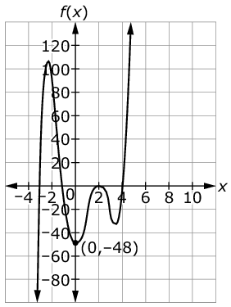

- (SBAC, 11) A ball is thrown in the air. The height of the ball in terms of time is modeled by the graph shown. A second ball is thrown from a lower initial height and reaches a higher maximum height.  - Select an equation that represents the height of the second ball in terms of time.  - Use the Add Point tool to plot two points on the grid: the initial height of the second ball and its maximum height. | 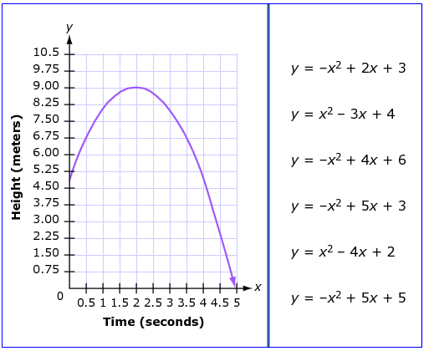

- (IMP) Which of the following equations could describe the function whose graph is shown? |  | 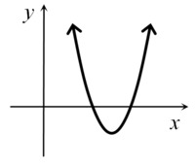
$$f_{1}\left(x\right)={\left(x+12\right)}^{2}-4$$  $$f_{2}(x)=-{\left(x-2\right)}^{2}-1$$  $$f_{3}(x)={\left(x+18\right)}^{2}-40$$  $$f_{4}(x)={\left(x-12\right)}^{2}-9$$ | $$f_{5}(x)=-4(x+2)(x+3)$$  $$f_{6}(x)=(x+4)(x-6)$$  $$f_{7}(x)=(x-12)(-x+18)$$  $$f_{8}(x)=(24-x)(40-x)$$

- (IMP) The school assembly is being held over the lunch hour in the school gym. All the teachers and students are there by noon and the assembly begins. About 45 minutes after the assembly begins, the temperature within the gym remains a steady 77 degrees Fahrenheit for a few minutes. As the students leave after the assembly ends at the end of the hour, the gym begins to slowly cool down.
Let $T$ denote the temperature of the gym in degrees Fahrenheit and $M$denote the time, in minutes, since noon.
  - Is $M$ a function of $T$? Explain why or why not.
  - Explain why $T$ is a function of $M$, and consider the function $T=g(M).$Interpret the meaning of $g(0$) in the context of the problem.
  - Becky says: “The temperature increased 5 degrees in the first half hour after the assembly began.” Which of the following equations best represents this statement? Explain your choice.

- $g(30)=5$ | - $\frac{g\left(30\right)-g\left(0\right)}{30}=5$ | - $g(30)-g(0)=5$ | - $T=g(30)-5$
  - Which of these choices below represents the most reasonable value for the quantity $\frac{g\left(75\right)-g\left(60\right)}{15}$? Explain your choice:
- 4 | - 0.3 | - 0 | - -0.2 | - -5

Links: illustrativemathematics.org, smarterbalanced.org

