The Equation of the Parabola Function I

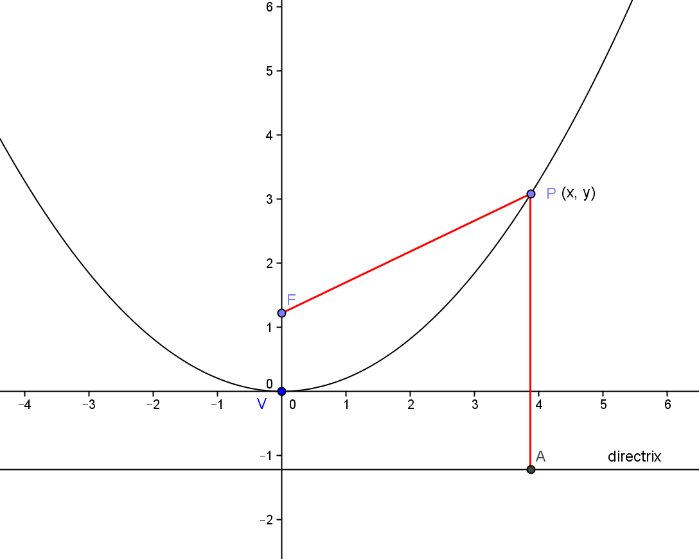
Since the distance from any point P(x, y) on the parabola to the focus F(0, p) is the same as the distance from P(x, y) to the directrix, y = -p , we can use the distance formula:

$$\sqrt{{\left(x-0\right)}^{2}+{\left(y-p\right)}^{2}}=y+p$$

And from this we get $x^{2}+{\left(y-p\right)}^{2}= {(y+p)}^{2}$.

Expanding both sides gives $x^{2}+y^{2}-2yp+p^{2}= y^{2}+2yp+ p^{2}$.

Cancelling and regrouping gives $x^{2}= 4yp$ or ${\frac{1}{4p}x}^{2}= y$. Notice that in the parabola, the x is of second degree and the y is linear.

A similar argument produces the equation of the parabola that opens down.

