Name ______________________________________ Period _____ Date __________
1

How Does Alice Grow?

Directions: In this project you will be drawing a “life-sized” Alice (as a stick-ﬁgure) before she drinks her potion and again after she drinks once, twice, and three times.

- Your Alice is 6 feet tall. She drinks a potion labeled . This is the scale factor. If she drinks from this potion 3 times, how can we represent her ﬁnal height using exponential notation?
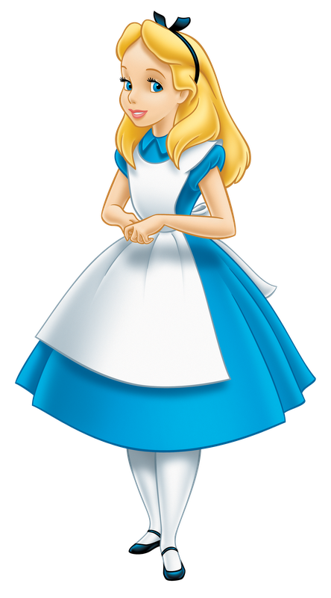

2.Complete the following table.
Starting Height | Scale Factor | # of Drinks | Exponential Notation | Standard Form
6 feet |  | First
6 feet |  | Second
6 feet |  | Third

- We don’t want a telescoping Alice, so we need to keep our drawing of her proportional. The most prominent feature on our stick ﬁgure is the head. Measure the head size of someone in your group and compare this to his or her height. If your Alice starts with a height of 6 feet, how long and how wide should her head be?

Either write a sentence or a mathematical expression that shows how you found this.
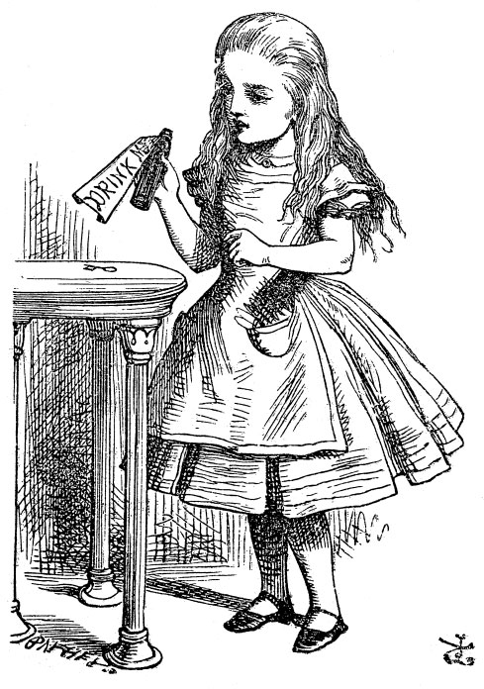

Name ______________________________________ Period _____ Date __________
2

How Does Alice Grow?

Directions: In this project you will be drawing a “life-sized” Alice (as a stick-ﬁgure) before she drinks her potion and again after she drinks once, twice, and three times.

- Your Alice is 6 feet tall. She drinks a potion labeled . This is the scale factor. If she drinks from this potion 3 times, how can we represent her ﬁnal height using exponential notation?

2.Complete the following table.
Starting Height | Scale Factor | # of Drinks | Exponential Notation | Standard Form
6 feet |  | First
6 feet |  | Second
6 feet |  | Third

- We don’t want a telescoping Alice, so we need to keep our drawing of her proportional. The most prominent feature on our stick ﬁgure is the head. Measure the head size of someone in your group and compare this to his or her height. If your Alice starts with a height of 6 feet, how long and how wide should her head be?

Either write a sentence or a mathematical expression that shows how you found this.

Name ______________________________________ Period _____ Date __________
3

How Does Alice Grow?

Directions: In this project you will be drawing a “life-sized” Alice (as a stick-ﬁgure) before she drinks her potion and again after she drinks once, twice, and three times.

- Your Alice is 4 inches tall. She drinks a potion labeled . This is the scale factor. If she drinks from this potion 3 times, how can we represent her ﬁnal height using exponential notation?

2.Complete the following table.
Starting Height | Scale Factor | # of Drinks | Exponential Notation | Standard Form
4 inches |  | First
4 inches |  | Second
4 inches |  | Third

- We don’t want a telescoping Alice, so we need to keep our drawing of her proportional. The most prominent feature on our stick ﬁgure is the head. Measure the head size of someone in your group and compare this to his or her height. If your Alice starts with a height of 4 inches, how long and how wide should her head be?

Either write a sentence or a mathematical expression that shows how you found this.

Name ______________________________________ Period _____ Date __________
4

How Does Alice Grow?

Directions: In this project you will be drawing a “life-sized” Alice (as a stick-ﬁgure) before she drinks her potion and again after she drinks once, twice, and three times.

- Your Alice is 2 inches tall. She drinks a potion labeled 3. This is the scale factor. If she drinks from this potion 3 times, how can we represent her ﬁnal height using exponential notation?

2.Complete the following table.
Starting Height | Scale Factor | # of Drinks | Exponential Notation | Standard Form
2 inches | 3 | First
2 inches | 3 | Second
2 inches | 3 | Third

- We don’t want a telescoping Alice, so we need to keep our drawing of her proportional. The most prominent feature on our stick ﬁgure is the head. Measure the head size of someone in your group and compare this to his or her height. If your Alice starts with a height of 2 inches, how long and how wide should her head be?

Either write a sentence or a mathematical expression that shows how you found this.

Name ______________________________________ Period _____ Date __________

Directions: complete the following table. In the column labeled with a plus sign jot down things you liked about the activity. In the column labeled with a ∆ write things you would change about the activity. Finally, under the question mark write question or concerns you have about the activity.

+ | ∆ | ?

Name ______________________________________ Period _____ Date __________

Directions: complete the following table. In the column labeled with a plus sign jot down things you liked about the activity. In the column labeled with a ∆ write things you would change about the activity. Finally, under the question mark write question or concerns you have about the activity.

+ | ∆ | ?

