Dr. Ivan Cheng is a Professor of Secondary Education at California State University Northridge. With over 23 years of teaching experience at the middle school and high school level, Dr. Cheng was one of the first math teachers to receive National Board certification in LAUSD. He is currently the Principal Investigator of the i3 CREATE Project and was a PI of the SITTE Project as well as a lead developer for coaching in the i3 SLOPE Project. Dr. Cheng has presented at numerous conferences and provides training for in-service and pre-service teachers across the state. He has a mathematics degree from UCLA and a master’s in mathematics education from CSUN. Dr Cheng is passionate about providing equity and access for all students in mathematics education and is known for his emphasis on “getting through to the students rather than getting through a textbook.”

Sunny Chin-Look is a National Board Certified Teacher (NCBT). She has been an instructional specialist for mathematics at Alhambra Unified School District since 2005, providing professional development and classroom support for K-8 teachers. Prior to that, she taught math in middle school and high school for 15 years. She served as a member on the California CCSSM Framework Committee. In addition, she is a consultant for UCLA Curtis Center, delivering math workshops for K-8 teachers.

Kristin Hartloff has been an educator for 15 years, as a teacher, Instructional Coach, and TOSA. She is currently the Secondary STEM TOSA in Tustin Unified. As a TOSA, she supports classroom teachers and administrators with content-specific curriculum, research-based instructional strategies, differentiation, and student engagement. She helped to lead the work in TUSD in developing our secondary math curricular units, and coordinate professional development opportunities for teachers led by teachers and professionals in the field. She is passionate about STEM, and her work centers around building capacity in district teacher and administrator leaders to arm students with the skills needed to succeed in STEM fields.

Rosa Serratore is a former middle and high school mathematics teacher. She has been an educator for more than 25 years. In her role of district mathematics coordinator, Rosa provides leadership and training on the implementation of mathematics standards. Her mission is to support teachers in effective instructional strategies, formative assessment use, data analysis, and use of curriculum guides and resources to help anchor professional learning communities and lesson study teams that design and collaborate in mathematics. Rosa was selected by the California Department of Education to participate in the writing of the mathematics framework using the new state standards. She currently serves on the executive board of CMC and has recently participated in UC/CSU Mathematics Diagnostic Testing Project. Dr. Norman Webb used her local and state knowledge and expertise in a recent NAEP/ACT content alignment study. In all ventures, outstanding mathematics instruction and learning for all students is Rosa’s goal.

Carolee Koehn Hurtado
Director, UCLA Parent Project
Director, UCLA Mathematics Project
UCLA Graduate School of Education and Information Studies, Center X

Carolee Koehn Hurtado serves as the Director of the UCLA Parent Project and UCLA Mathematics Project at UCLA Graduate School of Education and Information Studies. These projects are housed in Center X, where research and practice intersect to provide high quality learning opportunities for educators and families in public schools. Goals for this work include increasing dialogue and collaboration between school and home to provide spaces for meaningful engagement and increased student success.

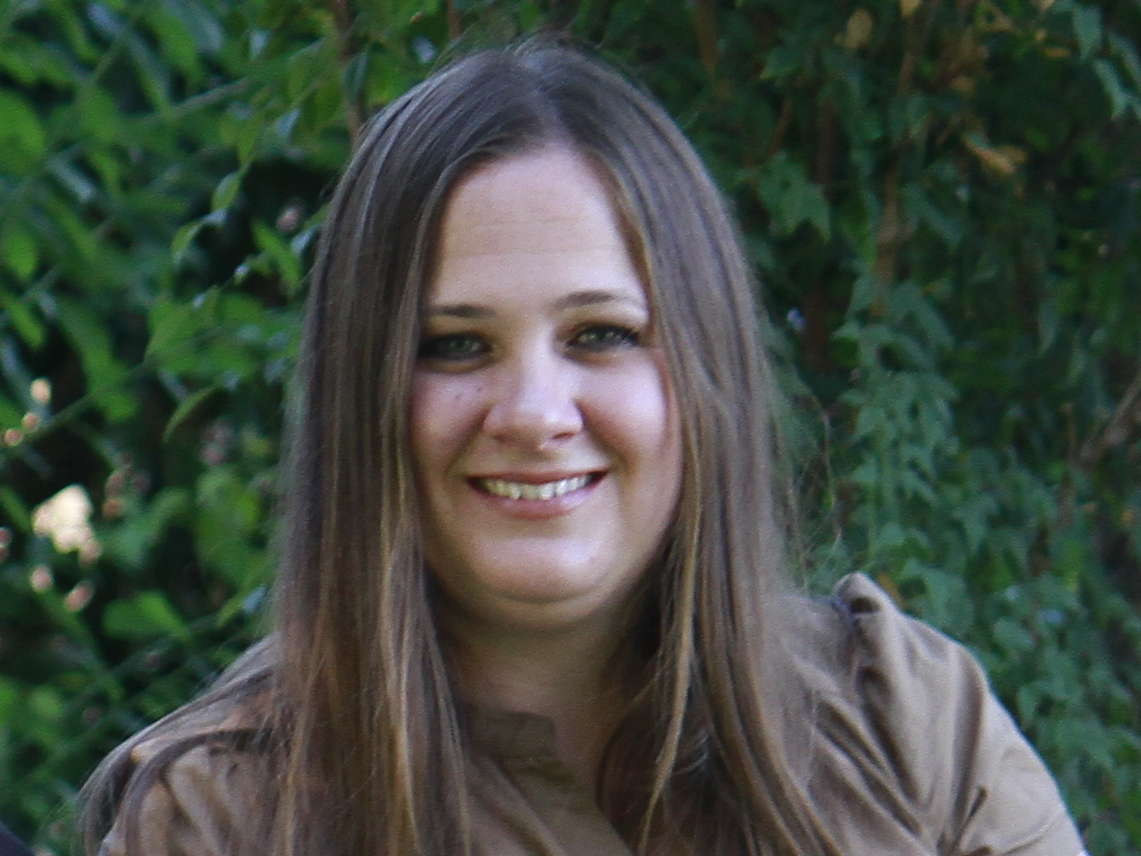

Dr. Ilene Straus, vice president of the state Board of Education, has served on the board since 2011. She was assistant superintendent for Educational Services in the Beverly Hills Unified School District before retiring in June, 2011. Prior to that, she was a teacher and an elementary, middle, and high school principal. Straus received her bachelor’s degree and elementary teaching credential from UCLA, her master's degree in educational administration from Cal State - Northridge, and her doctorate in educational leadership from USC.
Straus began her career as a teacher in the Lennox School District, and served as an assistant principal at two large K-6 schools before becoming a K-7 principal in the Norwalk-La Mirada Unified School District. She was named principal of Lincoln Middle School in Santa Monica where she served for 16 years, leading the school to national distinction as the Disney School of the Year, a National Blue Ribbon School of Excellence, and twice recognized as a California Distinguished School. Straus was named the California Secondary Principal of the Year in 1991, and received the YWCA Woman of the Year Award in 1996.
In 2002, Straus was named chief educational officer-principal of Santa Monica High School, where she guided the redesign of a large comprehensive high school into six smaller learning communities, helping the school to raise its academic performance index, which had been declining before her arrival, by 75 points. The U.S. Department of Education declared the school a national model for high school redesign, and Newsweek named it one of the country’s top 300 performing high schools. Straus next served as the senior director of Secondary Education for Santa Monica-Malibu Unified School District, and joined Beverly Hills Unified School District in the fall of 2006 as assistant superintendent, where she developed stronger high school graduation requirements and intervention programs to support student success, as well as initiatives in mathematics and literacy.
Dr. Straus has taught graduate courses in educational leadership and policy, supervision, curriculum and instruction at UCLA, USC, Cal State-Northridge and Loyola Marymount University, and currently teaches in the doctoral program at UCLA. Dr. Straus focuses her time on State Board of Education priorities and responsibilities, consulting with school districts, and graduate teaching.

