Some of the problems below can be solved by multiplying 3 x 6. Some of the problems need a different operation. Select the ones that can be solved by multiplying these two numbers. For the other problems, tell what operation is appropriate. Solve all problems and include appropriate units in the answer.
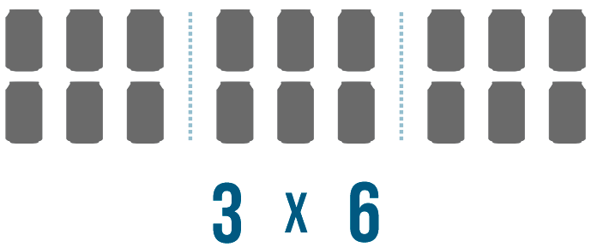
- Dina drew 6 triangles. How many sides did Dina draw altogether?

- Owen is building a rectangular tile patio that is 3 tiles wide and 6 tiles long. How many tiles does he need?

- Nina can practice a song 3 times in an hour. If she wants to practice the song 6 times before the recital, how many hours does she need to practice?

- Liam is cooking potatoes. The recipe says you need 6 minutes for every pound of potatoes you are cooking. How many minutes will it take for Liam to cook 3 pounds of potatoes?

- There are 3 peanut butter cups and 6 pieces of licorice in each package. How many pieces of candy are there?

- A Lego set cost $6. A K-nex set costs 3 times as much as the Lego set. How much does the K-nex set cost?

Yes: 1, 2, 4, 6
No: 3, 5

