To Multiply or Not To Multiply: Some of the situations below can be represented by multiplying (x ± a)(y ± b) where a and b are real numbers. Select the situations that can be represented by multiplying these two binomials. For the remaining, tell what representation is appropriate.
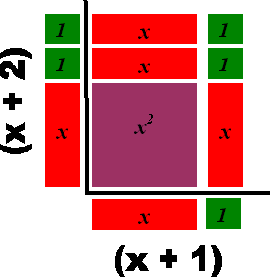

- If the price of a ticket to a concert is increased by $10, the number of people who will attend is decreased by 100. Represent the revenue for this event.

- For a sale the store reduced its prices by 20%. After the sale the store increased its prices by 20%. Represent the resulting price.

- A train makes a trip at a constant speed. Had its speed been 5 miles per hour faster, the trip would have taken 24 fewer minutes. If its speed had been 4 miles per hour slower, the trip would have taken 24 minutes longer. Write a mathematical statement that represents this scenario.

- You have 100 ft. of fencing to build a rectangular enclosure. You are enclosing an area of 500 sq. ft. Write a mathematical statement that will help you find the dimensions of the enclosure.

- Jose makes $20 an hour as a warehouse manager. He works too many hours a week. He wants to work 10 hours less but maintain his current weekly salary. How much more does he need to make per hour? Write a mathematical statement that represents this scenario.

Yes: 1, 3, 5 No: 2, 4

