Some of the situations below can be represented by adding 4 + 4 + 4. Some of the situations need a different representation. Select the ones that can be solved by adding 4 +4 + 4. Justify your response. For the other situations, show a representation that is appropriate.
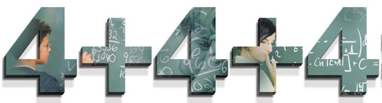
- Maria has 4 Girl Scout cookies. Her friends Lisa and Dina each have 4 Girl Scout cookies. How many Girl Scout cookies did they have?

- Jose made a square out of toothpicks. Then he made two more squares using more toothpicks. How many toothpicks did Jose use?

- Ryan likes toy cars. His friend Jordan and he each have 4 cars. How many cars do they have?

- Darnell and his two brothers each have a 4-wheel toy car. How many wheels are there?

- Yoshiko has twelve candies. Four candies are in her bag. Four more candies are in her desk. The rest of the candies are in her pocket. How many candies are in her pocket?

Yes: 1, 4 No: 3, 5 Maybe - 2

