What Comes Before the Standard Algorithm?
Valerie Henry, Ed.D., UC Irvine School of Education
vhenry@uci.edu http://ccssmlibrary.blogspot.com/

Developing Computational Fluency: Multi-Digit Addition and Subtraction
 | CA | CCSS
Add and subtract within 20, demonstrating fluency for addition and subtraction within 10. Use strategies such as counting on; making ten; decomposing a number leading to a ten; using the relationship between addition and subtraction; and creating equivalent but easier or known sums. |  | 1
Add within 100, including adding a two-digit number and a one-digit number, and adding a two-digit number and a multiple of 10, using concrete models or drawings and strategies based on place value, properties of operations, and/or the relationship between addition and subtraction; relate the strategy to a written method and explain the reasoning used. Understand that in adding two-digit numbers, one adds tens and tens, ones and ones; and sometimes it is necessary to compose a ten. |  | 1
Add and subtract within 1000, using concrete models or drawings and strategies based on place value, properties of operations, and/or the relationship between addition and subtraction; relate the strategy to a written method. Understand that in adding or subtracting three digit numbers, one adds or subtracts hundreds and hundreds, tens and tens, ones and ones; and sometimes it is necessary to compose or decompose tens or hundreds. |  | 2
Fluently add and subtract within 1000 using strategies and algorithms based on place value, properties of operations, and/or the relationship between addition and subtraction. |  | 3
Fluently add and subtract multi-digit whole numbers using the standard algorithm. | 2,3 | 4

Multi-Digit Addition with Properties of Operations and Place Value
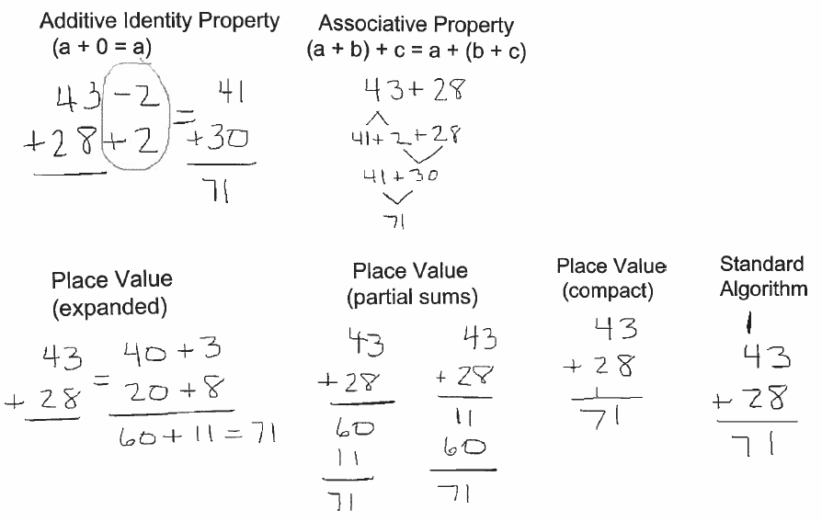

The Properties of Operations (adapted from CCSS-M)
(also known as the Field Properties)

Name of Property | Addition | Multiplication
Commutative | a + b = b + a | a x b = b x a
Associative | (a + b) + c = a + (b + c) | (a x b) x c = a x (b x c)
Identity | a + 0 = 0 + a = a | a x 1 = 1 x a = a
Inverse | For every a there exists -a so that a + (-a) = (-a) + a = 0 | For every a≠0 there exists 1/a so that ax1/a = 1/a x a = 1
Property Relating Addition and Multiplication
Distributive | a x (b + c) = a x b + a x c | (a + b) x c = a x c + b x c
 | a x b + a x c = a x (b + c) | a x c + b x c = (a + b) x c
 | (c≠0) | (c≠0)

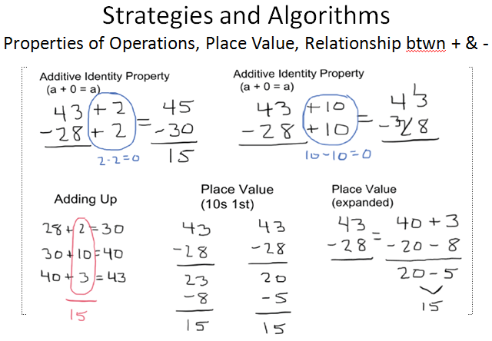18
Multi-Digit Subtraction with Properties of Operations and Place Value

A Framework for Examining Algorithms
(from Hyman Bass, Teaching Children Mathematics, 2003, as found in Bassareaer, 2005)

- Accuracy (or reliability): the algorithm should always produce a correct answer
- Generality: the algorithm applies to all instances of the problem, or class
- Efficiency (or complexity): this refers to whether the cost (the time, effort, difficulty, or resources) of executing the algorithm is reasonably low compared to the input side of the problem
- Ease of accurate use (vs. proneness to error): the algorithm can be used reasonably easily and does not lead to a high frequency of error in use
- Transparency (vs. opacity): what the steps of the algorithm mean mathematically, and why they advance toward the problem solution, is clearly visible

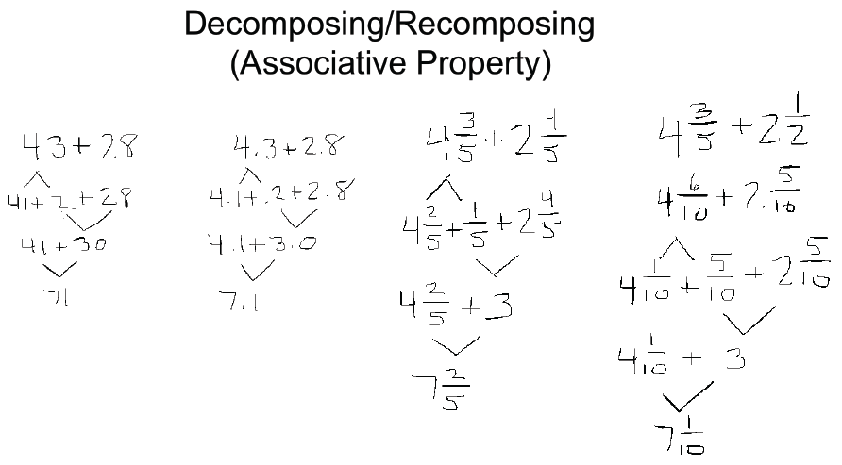

Developing Computational Fluency: Multi-Digit Multiplication and Division
 | CA | CCSS
Fluently multiply and divide within 100, using strategies such as the relationship between multiplication and division (e.g., knowing that 8 × 5 = 40, one knows 40 ÷ 5 = 8) or properties of operations. |  | 3
Multiply a whole number of up to four digits by a one-digit whole number, and multiply two two-digit numbers, using strategies based on place value and the properties of operations. Illustrate and explain the calculations by using equations, rectangular arrays, and/or area models. |  | 4
Fluently multiply multi-digit whole numbers using the standard algorithm. | 4 | 5
Find whole-number quotients of whole numbers with up to four-digit dividends and two-digit divisors, using strategies based on place value, the properties of operations, and/or the relationship between multiplication and division. Illustrate an explain the calculation by using equations, rectangular arrays, and/or area models. |  | 5
Fluently divide multi-digit numbers using the standard algorithm. | 5 | 6

Special Strategies
15 x 18  3 x 5 x 2 x 9  3 x (5 x 2) x 9  3 x 10 x 9  3 x 9 x 10  27 x 10  270 | 17 x 18  17 x 2 x 9  34 x 9  34 x 3 x 3  ? 102 x 3 ?  306 | 17 x 19

Don’t work the same way every time.

General Methods (aka Alternative Algorithms)
15  X 18  100  50  80  40  270 | 17  X 18  100  70  80  56  306 | 17  X 19  100  70  90  63  323

General Methods work the same way every time.

(Note: This Partial Products Alternative Algorithm requires students to pay attention to place values.)

The U.S. Standard Algorithm
4  15  x 18  120  15_  270 | 5  17  X 18  136  17_  306 | 6  17  x 19  153  17_  323

Standard Algorithms work the same way every time.

(Note: U.S. Standard Algorithms use single-digit computation,
and are often taught without connections to place value concepts.)

