Leaves and Caterpillars: The Case of David Crane

Students in David Crane's fourth-grade class were solving the following problem:

A fourth-grade class needs five leaves each day to feed its 2 caterpillars. How many leaves would they need each day for 12 caterpillars?

Mr. Crane told his students that they could solve the problem any way they wanted, but emphasized that they needed to be able to explain how they got their answer and why it worked.

As students worked in pairs to solve the problem, Mr. Crane walked around the room making sure that students were on task and making progress on the problem. He was pleased to see that students were using lots of different approaches to the problem—making tables, drawing pictures, and, in some cases, writing explanations.

He noticed that two pairs of students had gotten wrong answers as shown below. Mr. Crane wasn't too concerned about the incorrect responses, however, since he felt that once these students saw several correct solution strategies presented, they would see what they did wrong and have new strategies for solving similar problems in the future.
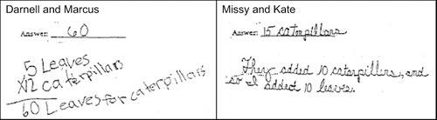

When most students were finished, Mr. Crane called the class together to discuss the problem. He began the discussion by asking for a volunteer to share their solution and strategy, being careful to avoid calling on the students with incorrect solutions. Over the course of the next 15 minutes, first Kyra, then Jason, Jamal, Melissa, Martin and Janine volunteered to present the solutions to the task that they and their partner had created. Their solutions are shown on the next page. During each presentation, Mr. Crane made sure to ask each presenter questions that helped them to clarify and justify their work. He concluded the class by telling students that the problem could be solved in many different ways and now, when they solved a problem like this, they could pick the way they liked best because they all gave the same answer.
