Implementing “Common” Tasks in a Traditional Classroom   
A Problem A Day  
Easing into the Common Core

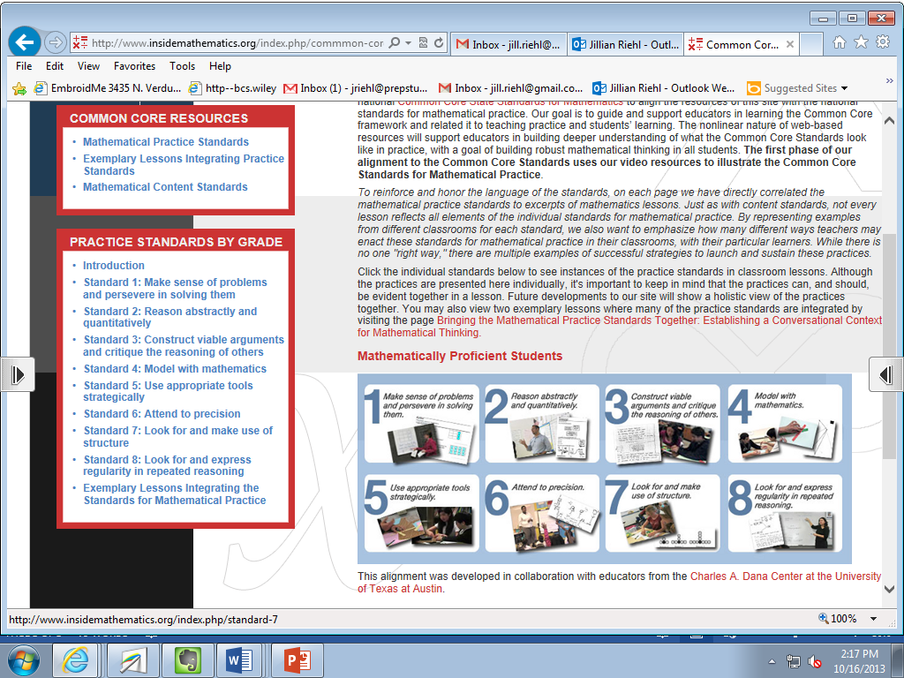

**What makes a problem “Common Core”?**

**PRACTICE STANDARDS:** Problems must meet at least 2

**SHORT:** 10-20 minutes long INCLUDING a final discussion

**BUT NOT TOO SHORT:** Students should have to consider what is being asked and discuss the problem with a classmate

**MULTIPLE APPROACHES:** Students are encouraged (and applauded) for finding a new method.







Source: [www.insidemathematics.org](http://www.insidemathematics.org)

Directions: Working with your neighbor, solve both problems below. Look for multiple Approaches for finding the solution. Then determine which practice standards each problem addresses. Be prepared to justify your choices!

------------------------------------------------------------------------------------------------------------------------------------------

**Problem Set #1 – Systems of Equations**

Solve the following system algebraically:

$$3y=x-2y-1$$

$$3x=2x-y-1$$

**TRADITIONAL**

In 1983, the composition of pennies in the United States was changed due, in part, to the rising cost of copper. Pennies minted after 1983 weigh 2.50 g, while the earlier pennies weigh 3.11 g.

1. A roll of pennies contains 50 coins. If a particular roll of pennies weighs 138.42 g, how many of the heavier pennies and how many of the lighter pennies does this roll contain?
2. Suppose you measure a roll of pennies on a scale which only reads the weight to the nearest gram. The scale says that the roll of pennies weighs 131 grams. What can you conclude about the pennies in this roll? What if the roll weighs 134 grams? Explain.
3. Some references list the weight of the newer pennies as 2.5 grams instead of 2.50 grams. If you only knew that the measurement of 2.5 grams was precise to the nearest tenth of a gram, what can you conclude about the pennies in the roll if the scale reads 138.4 grams?

Source: [*www.illustrativemathematics.com*](http://www.illustrativemathematics.com)

**COMMON CORE**

**Additional Sample Problem Set – Radical Expressions**

**TRADITIONAL**

Simplify.

$$\frac{\sqrt{135}}{\sqrt{35}}$$

**COMMON CORE**

Put in order from least to greatest without a calculator





**Additional “Common Core” Problems**

*Topic: Graphing Quadratics*

*Source:* [*http://map.mathshell.org/*](http://map.mathshell.org/materials/index.php)

*Topic: Simplifying Rational Expressions*

*Written by Jill Riehl*

Complete the blanks with a sign (either $<, >, =$) that satisfies the statement.

1. ( $2\sqrt{3}+5)(2\sqrt{3}-5)$ $\frac{1}{4-\sqrt{15}}$

$\frac{5+\sqrt{2}}{5-\sqrt{2}}$ $\frac{2\sqrt{7}+1}{3}*\frac{2\sqrt{7}-1}{3}$

$\frac{\sqrt{6}}{\sqrt{2}+\sqrt{3}}$ $\frac{3}{\sqrt{5}+\sqrt{2}}$

$\sqrt{\frac{75}{2}}-\sqrt{\frac{3}{2}}$ $\frac{\sqrt{18}-\sqrt{6}}{\sqrt{2}}$

____
2. _____
3. _____
4. ______

*Topic: Quotients of Rational Expression*

*Written by Jill Riehl*

For what values of x will the quantity $\frac{x^{2}-4}{2x^{2}-5x+2}÷\frac{2x^{2}-3x-2}{4x^{2}-1}$ be negative?

*Topic: Rational and Irrational Numbers*

*Source:* [*www.illustrativemathematics.com*](http://www.illustrativemathematics.com)

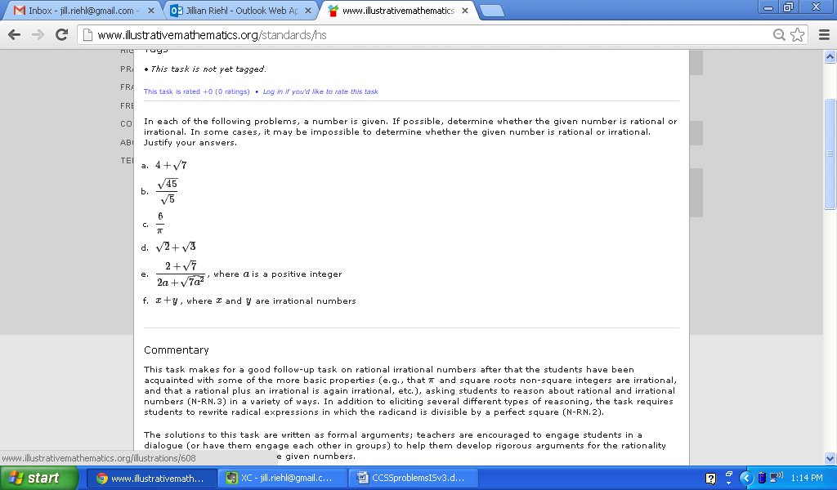

*Topic: Quadratic Forms*

*Source:* [*www.illustrativemathematics.com*](http://www.illustrativemathematics.com)

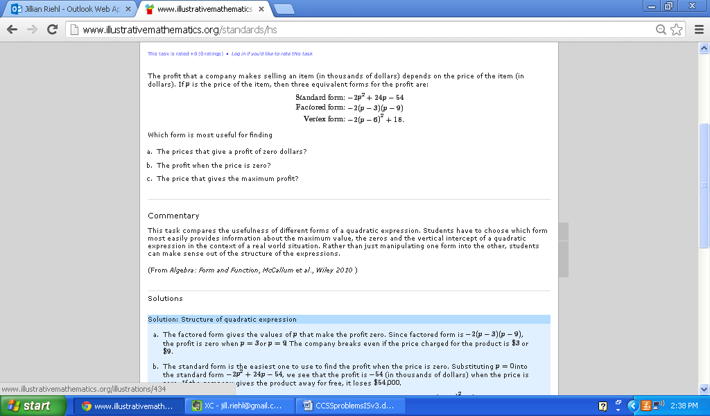

**References**

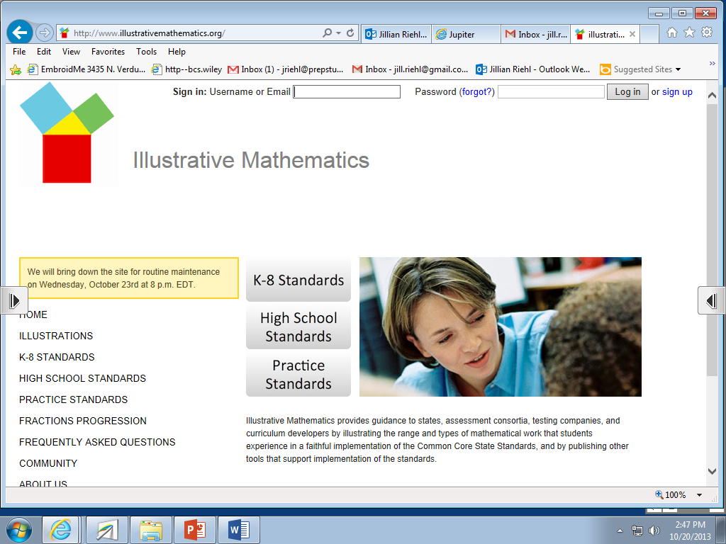

[www.illustrativemathmatics.org](http://www.illustrativemathmatics.org/) (Problem B on in Problem Set #1, Additional problems #4 & 5)

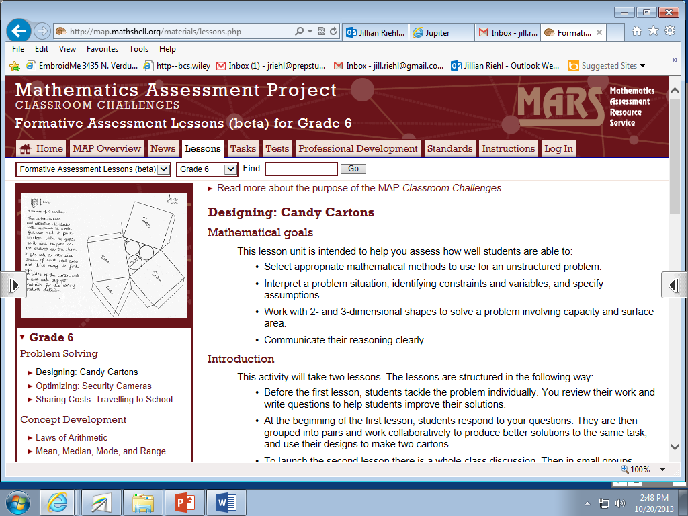

<http://map.mathshell.org/> (Additional problem #3 )

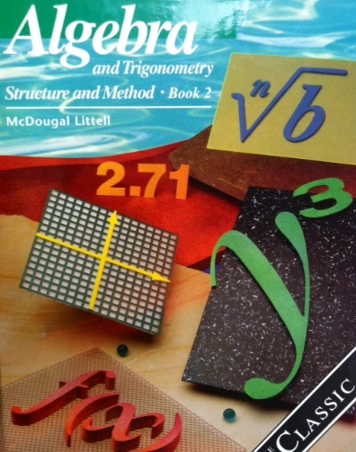

Textbook: *Algebra & Trigonometry Structure & Method, Book 2. McDougall Littell*