Launching into Inference:

From Common Core to AP Statistics

Daren Starnes

The Lawrenceville School

[dstarnes@lawrenceville.org](mailto:dstarnes@lawrenceville.org)

CMC South 2013

Common Core State Standards in Mathematics

Making Inferences and Justifying Conclusions S-IC

**Understand and evaluate random processes underlying statistical experiments**

1. Understand statistics as a process for making inferences about population parameters based on a random sample from that population.

2. Decide if a specified model is consistent with results from a given data-generating process, e.g., using simulation. *For example, a model* *says a spinning coin falls heads up with probability 0.5. Would a result of 5* *tails in a row cause you to question the model?*

**Make inferences and justify conclusions from sample surveys, experiments, and observational studies**

3. Recognize the purposes of and differences among sample surveys, experiments, and observational studies; explain how randomization relates to each.

4. Use data from a sample survey to estimate a population mean or proportion; develop a margin of error through the use of simulation models for random sampling.

5. Use data from a randomized experiment to compare two treatments; use simulations to decide if differences between parameters are significant.

6. Evaluate reports based on data.

**HOW TO ORGANIZE A STATISTICAL INFERENCE PROBLEM: A 4-STEP PROCESS**

From *The Practice of Statistics,* 5th edition, by Starnes, Tabor, Yates, and Moore, W. H. Freeman and Co., in production

|  |  |  |
| --- | --- | --- |
|  | **Confidence intervals (CIs)** | **Significance tests** |
| **STATE:** | What*parameter* do you want to estimate, and at what *confidence level*? | What *hypotheses* do you want to test, and at what significance level? Define any *parameters* you use. |
| **PLAN:** | Choose the appropriate inference *method*. Check *conditions*. | Choose the appropriate inference *method*. Check *conditions.* |
| **DO:** | If the conditions are met, perform *calculations*. | If the conditions are met, perform *calculations*.  **•** Compute the **test statistic.**  **•** Find the ***P-*value.** |
| **CONCLUDE:** | *Interpret* your interval in the context of the problem. | *Interpret* your test result in the context of the problem. |

**Inference in a Nutshell**

Inference: Using sample data to draw conclusions about populations or treatments

|  |  |  |  |
| --- | --- | --- | --- |
| **Numerical summary** | **Parameter** | **Statistic** | **Type of Data** |
| Proportion | *p* |  | Categorical |
| Mean | *μ* |  | Quantitative |
| Standard deviation | *σ* |  | Quantitative |

Two main types of inference:

* Estimating Confidence intervals
* Testing claims Hypothesis tests/significance tests

**I. Estimating**

*What is a confidence interval?*

*How does a confidence interval work?*

The Pew Internet & American Life Project asked a random sample of U.S. teens, “Do you have a cell phone... or a Blackberry, iPhone or other device that is also a cell phone?” Based on this poll, the 95% confidence interval for the proportion of all U.S. teens that have a cell phone is (0.72,0.82).

*Source:* The 2011 Teens and Digital Citizenship Survey sponsored by the Pew Research Center’s Internet and American Life Project

(a) Interpret the confidence interval.

(b) What is the point estimate that was used to create the interval? What is the margin of error?

(c) Based on this poll, a newspaper report claims that more than 75% of U.S. teens have a cell phone. Use the confidence interval to evaluate this claim.

What does the confidence level mean? <http://www.math.usu.edu/~schneit/CTIS/CI/>

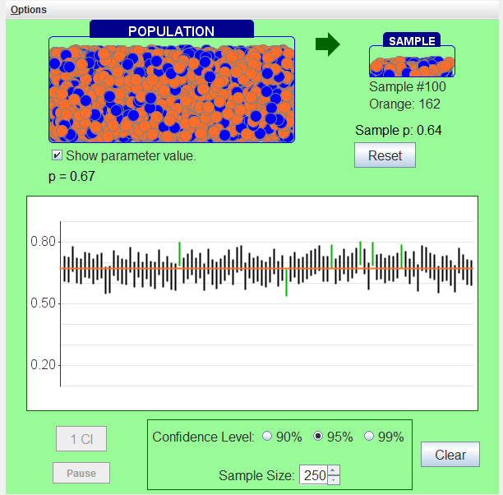

What can go wrong with a confidence interval?

It might not capture the parameter due to:

point estimate ± margin of error

statistic ± (critical value)(standard deviation of statistic)

**Why the Random, 10%, and Large Counts conditions are important**



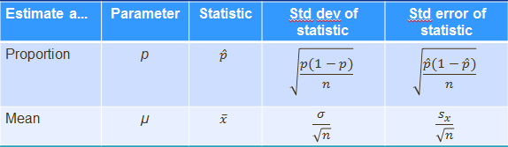

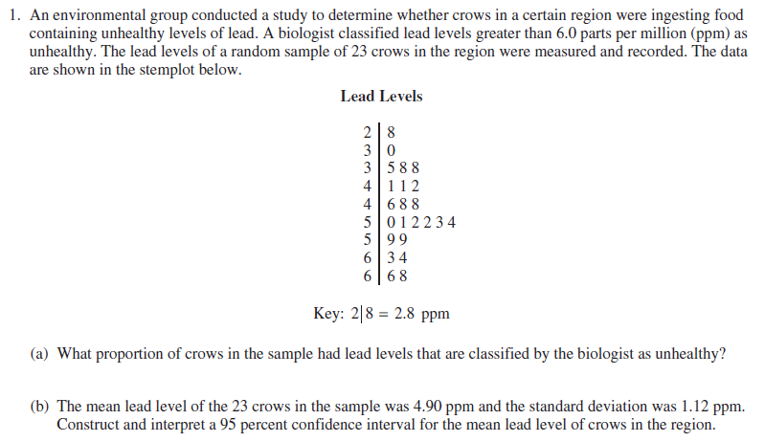

**II. Testing a claim**

*What is a significance test?*

*How does a significance test work?*

A virtual basketball player claims to make 80% of his free throws. We suspect he might be exaggerating.

Null hypothesis 

Alternative hypothesis 

<http://bcs.whfreeman.com/tps4e/#628644__666398__>

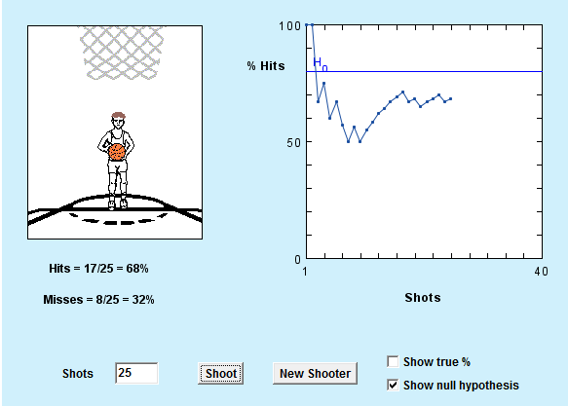

*What is a P-value, anyway?*

An observed result that is unlikely to occur just by chance when $H_{0}$ is true gives evidence that $H_{0}$ is NOT true.

*What conclusions can we draw?*

*What can go wrong with a significance test?*

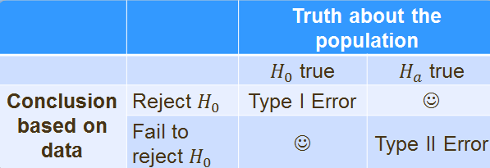

Type I error Reject $H_{0}$ when $H_{0}$ is true

Type II error Fail to reject $H_{0}$ when $H_{a}$ is true

